**Ideation Phase**

**Define the Problem Statements**

|  |  |
| --- | --- |
| Date |  |
| Team ID | NM2023TMID04504 |
| Project Name | Creating an email campaign in mailchimp |

**Problem Statement:**

"In today's dynamic interior design industry, Decor Delight faces the challenge of consistently delivering innovative and personalized design solutions that not only meet clients' aesthetic preferences but also align with their functional needs and lifestyle. This requires enhancing the design process, ensuring efficient project management, and effectively communicating design concepts to clients to achieve their utmost satisfaction while staying competitive in the market."

This problem statement highlights the key issues your project, Decor Delight, is addressing within the field of interior design. It emphasizes the need for innovation, personalization, efficiency, and effective client communication, which are essential aspects of the business. With this problem statement, you can now move on to the ideation phase to generate creative solutions to tackle these challenges.

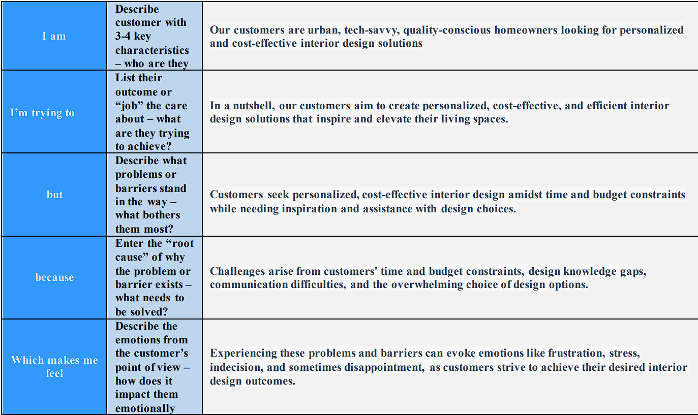

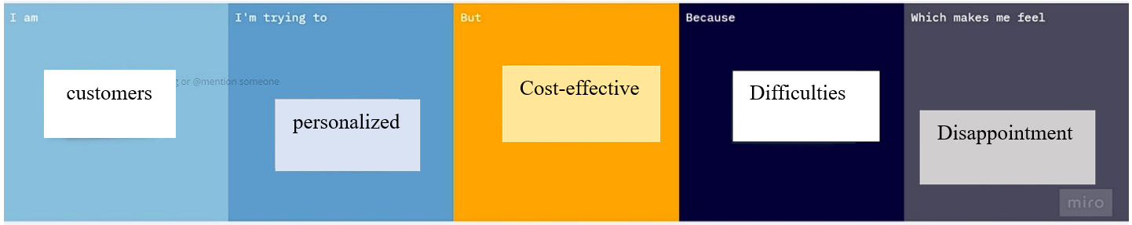

|  |  |  |  |  |  |
| --- | --- | --- | --- | --- | --- |
| **Problem Statement (PS)** | **I am (Customer)** | **I’m trying to** | **But** | **Because** | **Which makes me feel** |
| PS-1 | Our customers are urban, tech-savvy, quality-conscious homeowners looking for personalized and cost-effective interior design solutions | In a nutshell, our customers aim to create personalized, cost-effective, and efficient interior design solutions that inspire and elevate their living spaces. | Customers seek personalized, cost-effective interior design amidst time and budget constraints while needing inspiration and assistance with design choices. | Challenges arise from customers' time and budget constraints, design knowledge gaps, communication difficulties, and the overwhelming choice of design options. | Experiencing these problems and barriers can evoke emotions like frustration, stress, indecision, and sometimes disappointment, as customers strive to achieve their desired interior design outcomes. |